Specification
  - Extrusion: RECTANG 24

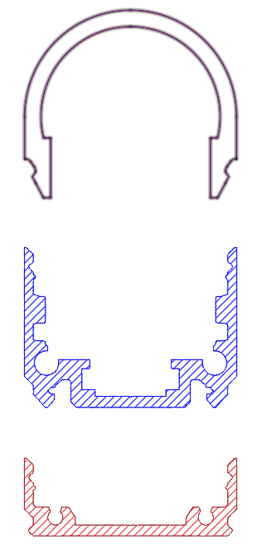

- The extrusion shall be made of aluminum.
- The extrusion shall be available in following surface finishes:
  - Blank
  - Anodized natural (thickness 15µm)
  - Anodized black (thickness 15µm)
  - Coated with polyester powder-coating in all standard RAL-colors
- The extrusion shall have following dimensions: 24mm x 18,25mm.
- The extrusion shall fit a PCB with a width of maximum 8mm.
- The extrusion shall be available in lengths up to 6m.
- The extrusion shall be compatible with following extruded PMMA covers:
  - Flat cover 5mm
  - Square cover 16,25mm
  - Round cover 16,25mm
  - Lens cover 11,7mm
- These covers shall be available in maximum 3m length.
- The extrusion shall be compatible with a clicking profile with following dimensions: 24mm x 8,7mm
- The extrusion shall have a compatible fully closed endcap.
- The extrusion shall have a compatible endcap with a hole for a cable.

